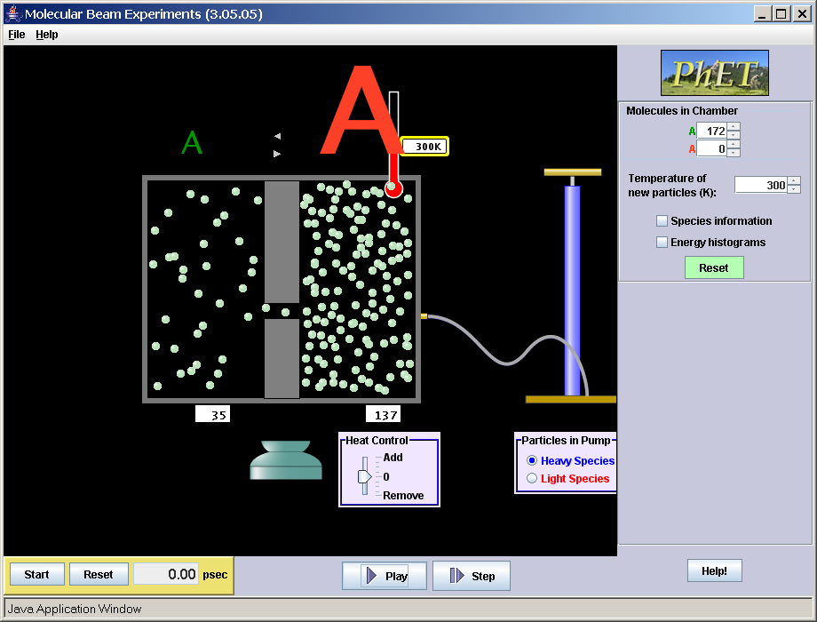

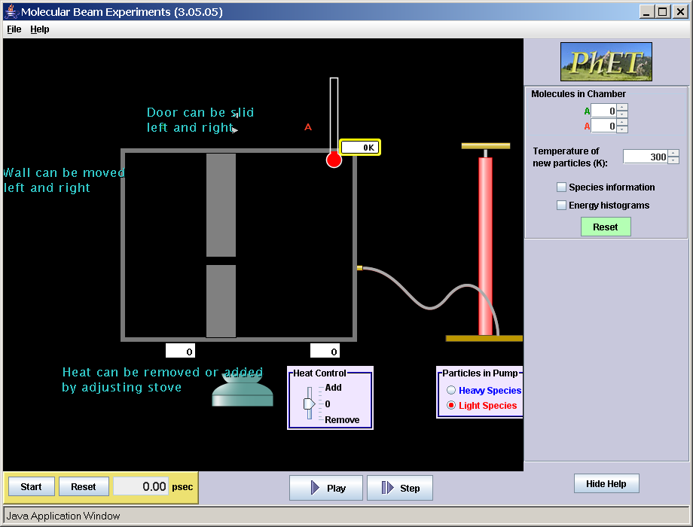

Things that work:
(All the features seen before Help is turned on except Molecule number.)
- Temperature controls
- Species information
- Energy histograms
- Reset
- Stopwatch
- Play/Pause/Step buttons
- Pump
- Heat control

There are some things that need to be fixed.
- Change the name Molecular beam (Diffusion/Effusion?)
- The number of Molecules in Chamber display is not counting correctly (In the top image, there are 137 in the right chamber and 0 is displayed).
- The help says the wall can move, but it doesn’t

Also, I think that learning goals need to be written. (I listed a few that come to mind)
- Graham’s law of effusion
Compare effusion rates of species of varying mass and temperature
Discuss how the hole size effects rate
- Rate of diffusion
Compare diffusion rates of species of varying mass and temperature
Discuss how the container size effects rate

Features that might be deleted/added/changed.
- I don’t like the large A’s that display relative amounts above the reaction vessel. Maybe more clear labels like left chamber and right and I think the way they change size is distracting taking away from the molecular representation. We use Pie, Bar and Strip in Reactions and let the used collect their own data in Salts.
- The little arrows above the divider don’t seem to have a purpose.
- Have another pump on the other side
- Make the tube greater variable length (like a zoom out feature)
- Help says “door can be slid left or right”, but the pieces move independently like dividers. I like moving them independently the Help needs to be changed
- Make it so the wall could be solid (no hole) or not present at all.

